**Spring** : Spring is a dependency injection framework.

Also it complements JEE standards and makes it easy for developers to use.

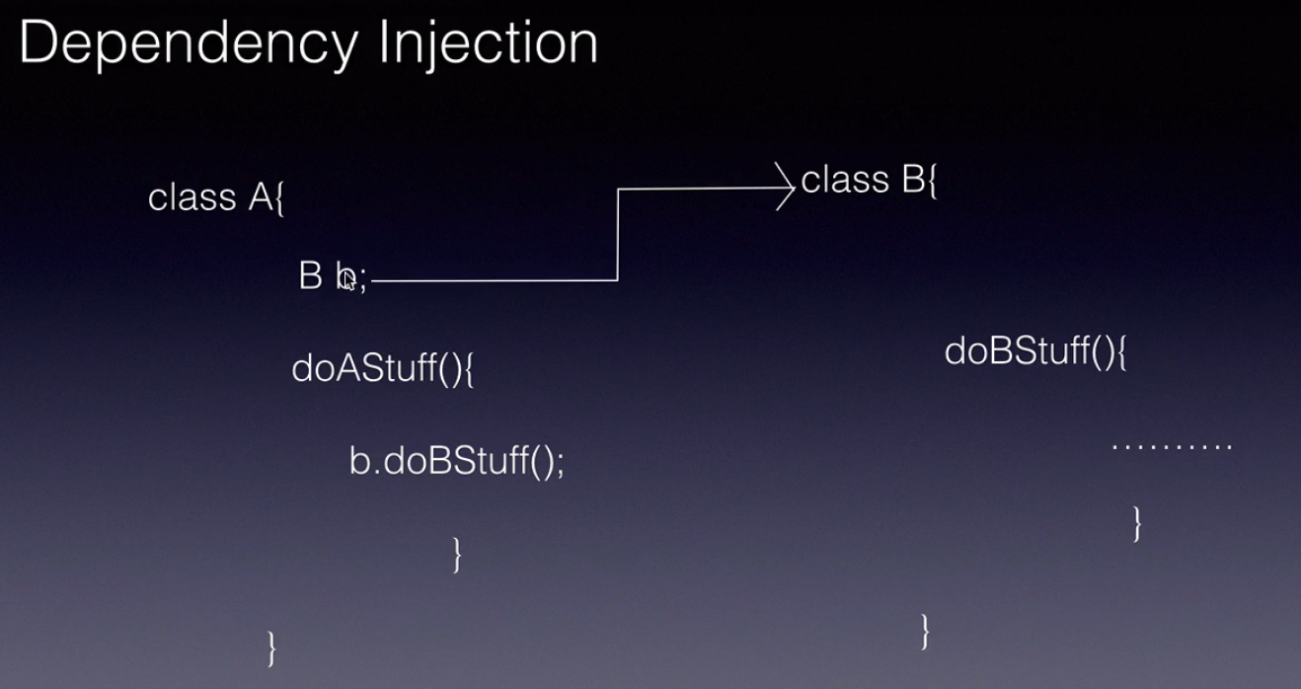

 When we develop software applications we organize our code across components in case of Java these components are classes.

Here I have Class A which depends on Class B to get its work done. So these components typically use each other. Instead of we creating an object of class B in class A we delegate this responsibility to frameworks like spring. Spring at runtime dynamically create an object of class B and it will inject it into Class A We as a developers can simply focus on our business logic instead of worrying about the object creation. This process of moving the control of object creation from the application code to a external framework is called inversion of control it is a design pattern. We are giving away the object creation control from our application code to a external framework or container like spring.

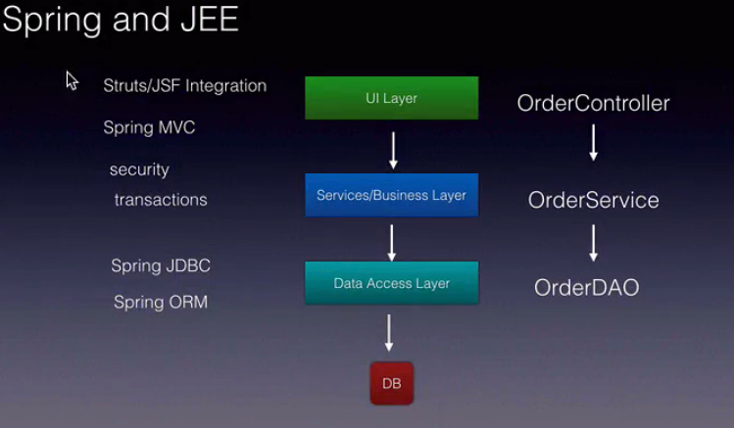

So where does Dependency Injection apply in case of JavaEE applications. Any java EE application if you take a look at it, it will be typically organized into layers UI layers, services layer, data access layer and more.

Each of these layers use the services provided by the layer below. For example, the UI layer we have order controller which an order service, the order service in turn will use the services provided by the order DAO.

This is where spring dependency injection will come in spring will automatically create the order DAO

it will inject it into the order service.It will automatically create the order service and inject it into the order controller. That is where dependency injection comes-in in JavaEE. Along with dependency injection,

the second thing I want you to understand is that spring makes it very easy for us the developers to

use the existing API's and frameworks.

For example, spring provides spring JDBC which you can think off as a wrapper around the JDBC standard

from oracle and as a developer we can execute sequel statement in one single line.

It will take away all the repeated code that is there in JDBC.

Similarly it will make our life very easy by providing spring ORM using spring ORM object relational

Mapping will be able to use ORM tools like hibernate in a very simple manner and in the UI layer it provides

integration with Struts java server faces to develop beautiful UI again in simple steps.

And also if the community or the people developers at Spring feel that a particular javaEE standard or a framework is difficult to use for example struts or even JSF then they come up with a parallel implementation.

One such implementation is the spring MVC.

Using this you can develop the web layer for your web applications.

And also spring provide services like security transaction management which we can simply configure and are

ready to use.

**Spring Modules**

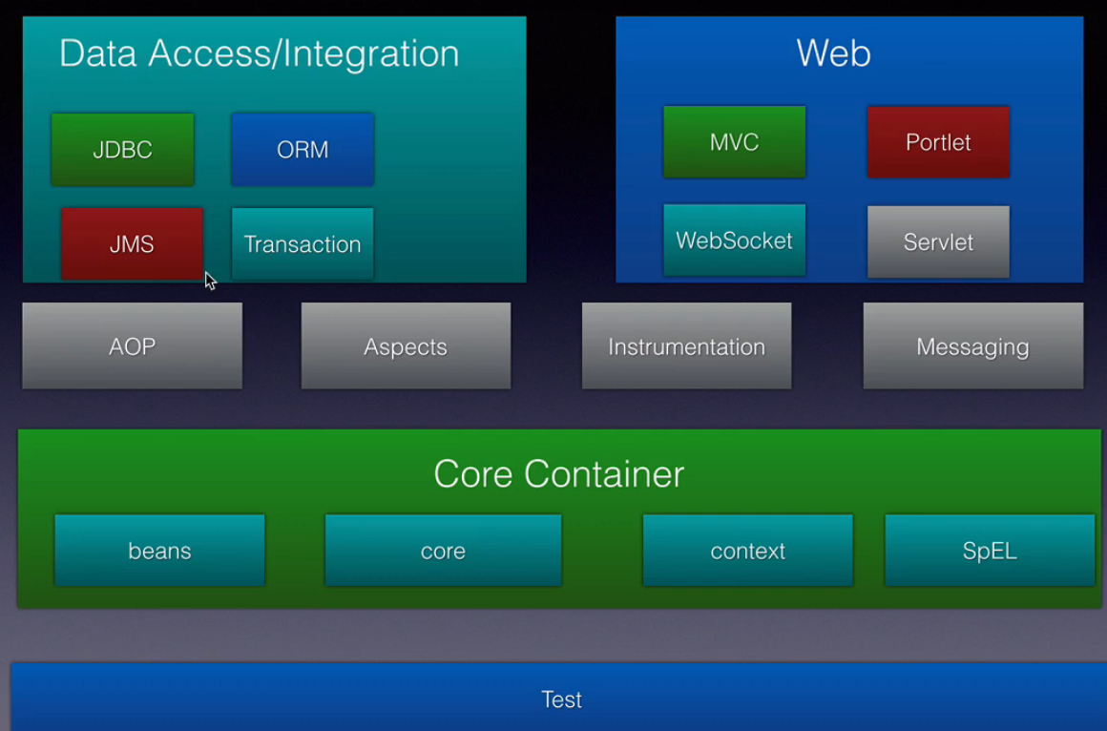

The spring frame work is made up of 20 plus modules they are categorized into the core container model the

data access module, web module, AOP, instrumentation, testing and many more.

And we use some of these modules as required by our application as per the requirements of our application

when we build them.

The core container module is the heart of the Spring Framework. It has the implementation for inversion of control and support for dependency injection. It is responsible for maintaining the object's lifecycle in our application that is creating the object dependent doing the dependency injection calling the init and destroy methods etc..

The data access module is a combination of multiple modules that is that JDBC ORM JMS transaction.

The JDBC module provides an abstraction layer over JDBC and makes it very easy for us the developers

to use the JDBC API with very few lines of code, you can perform JDBC operations or the database operations.

The ORM module integrates with ORM frameworks such as hibernate and we can use Hibernate and several

other ORM tools in very simple steps, using spring JMS support,We can send or produce and consume messages.A transaction is a atomic unit of work.

The transaction module supports both programmatic as well as declarative transaction management.

AOP stands for Aspected Oriented Programming.AOP allows us to inject code or services into our objects without modifying their classes.Using it we can configure cross-cutting concerns such as transaction management logging security etc.. Throughout our application the web module is one of the very important modules and very much used in the JavaEE application development.

It comprises of the core web the MVC module web socket servlet and portlet modules.

The core web module provides the basic web oriented features such as file uploads initialization of

the spring container on a application server through servlet listeners and web oriented spring container or application context,all that is a part of the web module or the web core module.

The spring MVC is a complete implementation of the model view controller pattern and this is used to develop dynamic web applications.

The Servlet module contains or it has the support for implementing basic web applications.

The portlet model provides the MVC implementation to be used in Portlet environment.

Last but not the least the testing module supports testing spring applications using JUnit and testNG.

It also provides Mock objects that allow us to test our application layers in a javaEE application

in isolation.

**Spring Container**

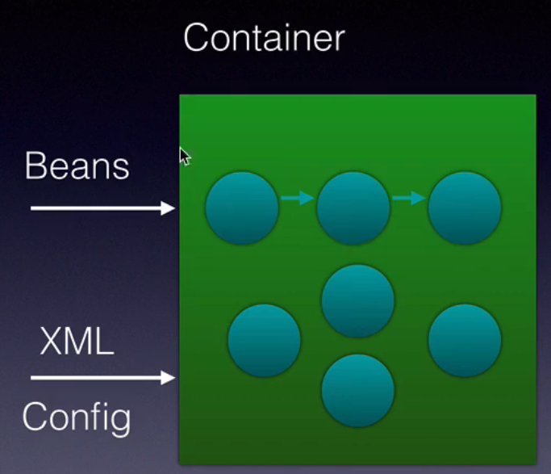

A container is a predefined program or component that comes with the Spring Framework and it is responsible

for creating the objects holding them in memory and also injecting them into another object as required.

so it maintains the complete lifecycle of an object from creation to destruction.

The container needs two things.

The first thing is the bean or the Java classes in our application for which we need objects to be created.

Second an xml configuration which we as developers will create through which we tell the container

what the dependencies are for a particular object and it creates an object it needs to know what that object

depends on.

That information is provided in the xml configuration. The container will take these two and create all the objects and maintain their lifecycle for us.

And our application code can then get these objects from the container by requesting for them.

The application context interface from Spring represents a container. It is an interface we cannot create instances of it.

And the implementations of this interface are **classpathxmlapplicationcontext,** **annotationconfiguration**

**applicationcontext** and **filesystemXMLapplicationcontext**.

The classpath xml application context will search for the xml configuration on the Java class

path. The file system xml application context as the name itself says it will search for the xml configuration

file on the file system instead of the Java classpath.

Finally the annotation configure application context is used when we configure the beans using annotations.

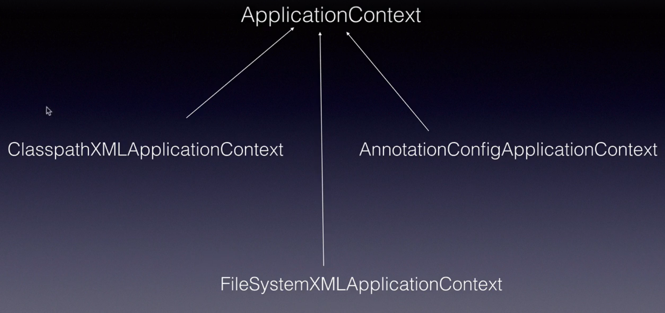

Two ways of Dependency inection: Dependency injection is basically a principle of injecting dependencies to other classes at runtime. There are two ways of doing it:

1. By using setter
2. By using Constructor

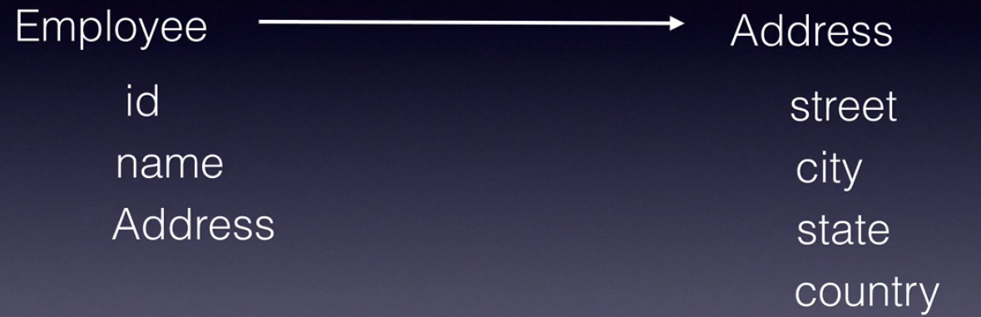

Lets say we have two classes Employee and Address where Employee class needs Address class objects to be stored. So this can be handled using DI.

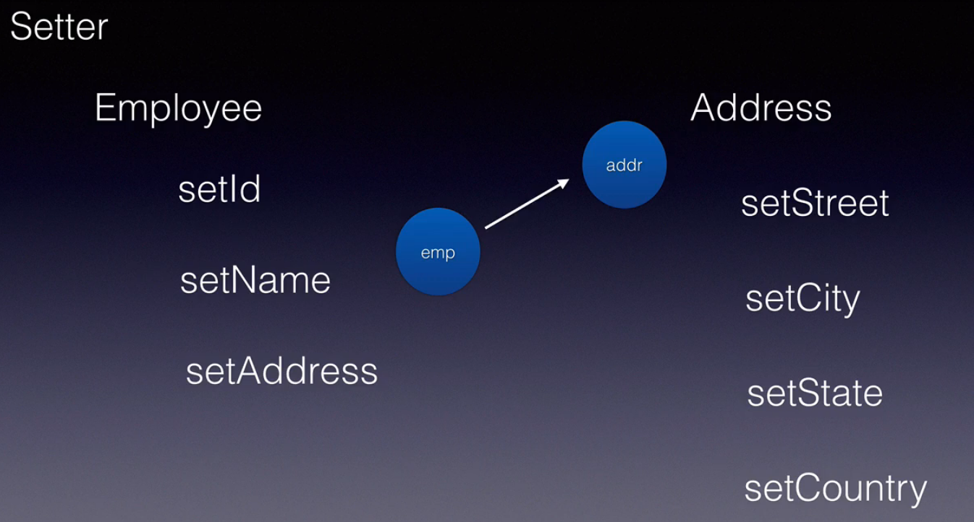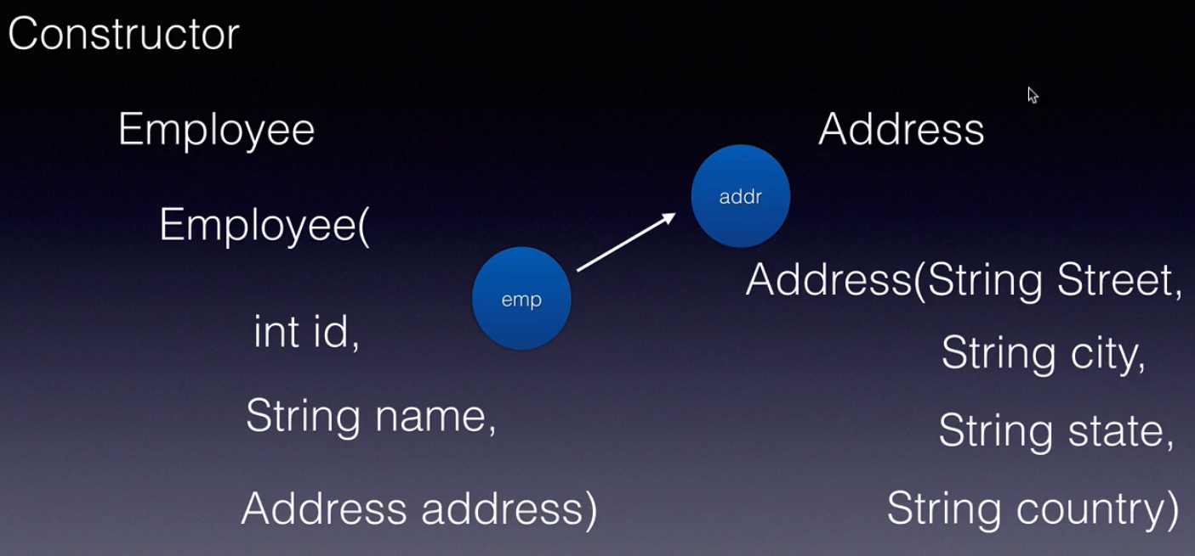

In first case, spring will invoke setter at runtime , while in second one Constructor is invoked at runtime.

In Setter injection values can be passed as element,attribute and also using **P schema/P namespace**.

In Constructor injection , value can be passed as tag, attribute and also using **C schema/C namespace**.

**Data Type Dependencies:**

When spring perform DI , it creates Object on the basis of data the object depends on . There are 3 types of dependencies:

* + - * Primitive Type dependencies(byte, short, int ,long and so on)
      * Collection Type(List,set,Map, Properties)
      * Reference(Class depends on other class)
      * And also using inner beans which is same as reference in some terms.

**Steps to Perform DI**

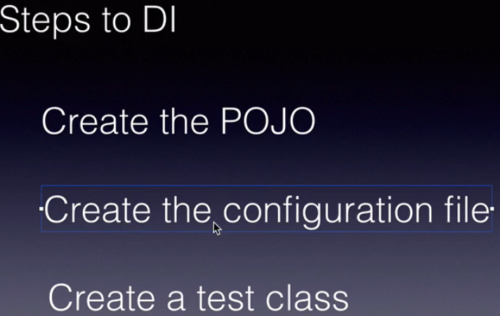

**Spring Lifecycle methods**

Spring provides two life cycle methods to every bean it creates.

They are the init method and the destroy method.

The names need not be the same but the signature should be exactly the same it should be public void

and no parameters. Any initialization code such as loading some configuration file from the file system or connecting to the database or connecting to a web service or a server can go into the init method.

We put that code inside the init method and all the cleanup code that is closing the connections or cleaning

up all the objects should go into the destroy method.

The lifecycle looks as follows given a spring bean and xml configuration to the spring container the

spring container will first instantiate an object of the bean. It will then set all the values onto that object.

Then it will invoke the init method whatever code we put into the init method will be executed at that

point.

After the data is set into the object.Then we read the bean make use of that bean in our application and once we are done and before the container is destroyed or object is destroyed the destroy method will be invoked before the destruction of the object the destroy method will be invoked and we put all the cleanup code inside the destroy method and then spring will destroy that object. if we are aware of servlets then you know the init and destroy method in servlet, these are very similar but what you need to remember is that the init method is called after the object is instantiated and all the properties are set on to the object that is all the dependencies are injected.

After that the init method is invoked and just before the object is destroyed the destroy method is

invoked.

You can configure the lifecycle methods in three ways:

1. using **xml configuration** (init-method & destroy-method)
2. using or implementing some **string interfaces**. our bean classes will implement these interfaces and override some methods (InitializingBean and DisposableBean)
3. by using **annotations**. ( @PostConstructor & @PreDestroy)

**NOTE:** By default Destroy method is not called in Spring , we need to call a method call “RegisterShutdownHook” to make Spring call destroy method.

Also By default annotation support is disable to enable it use(<context:annotation-config/>

We can make Dependency injection mandatory by using @Required annotation in beans. @Required cannot be used directly on fields. It should be placed on setters. Once we place this annotation and doesn’t pass any value.It will throw exception(BeanInitializationException) at runtime.

**Bean Scopes**

The scope is availability of the object in the container in simple words, it is the number of objects created in the container of a particular bean type.

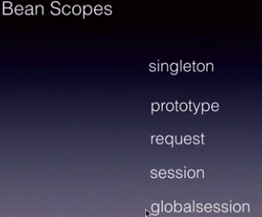

There are five possible values: **Singleton, prototype, request, session and finally global session**. Singleton

is the default value when we configure a bean in the spring configuration,and we do not provide any scope,

by default it is singleton.

The spring container if marked as **singleton** or if we don't specify anything on the bean will create only one object no matter how many times that bean is read and used in our application.

The second scope is the prototype scope.

If we mark bean as **prototype** then the container will create different objects of that type every time that object is read and used in our application.

Next is **request** as the name itself says the request scope is only relevant for spring MVC webapplications, when the request comes in from the end user or from the browser to our web application which is developed using spring. spring container will create an object per request per user request next session again.

**Session** is also relevant only for spring MVCweb applications.

A session is everything that happens between a user logon and Logout or everything that happens from the

time the user first access our website till the time he leaves our website if we mark a bean as

session scope then the spring container will create only one object for the entire session. If a new user session is created then another object will be instantiated by spring.

Last but not the least the **global session**, using this Global's session scoped spring container will create an object per global context.

This is used only in spring. MVC Portlet applications.

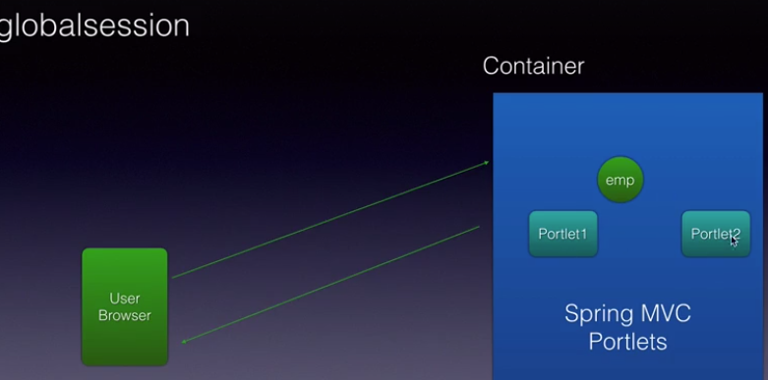

In Portlet applications there can be multiple Portlets, across these portlets there will be a global session.

global context and Spring container will create only one object for the entire global session

across these portlets.

**Note:** we can verify scopes by printing the hashcodes of two different objects called on the bean. If the hashcode is same it means, scope is singleton…if different then it is prototype.

**Constructor injection**

Constructor injection can have ambiguity problems if constructors are overloaded with different type arguments. By default Values passed using constructor injection are treated as Strings. If you don’t have a constructor defined with String arguments , it will pick up the first constructor it finds in class.

It can lead to ambiguity issues, if you want to pass int type values, but the first constructor u defined is having double values only.

To fix this we have an attribute available named as “type” which can be defined for the fields. 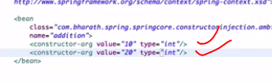So here for these two fields in constructor int type is declared and only integer type constructor will be invoked during runtime.

**AutoWiring**

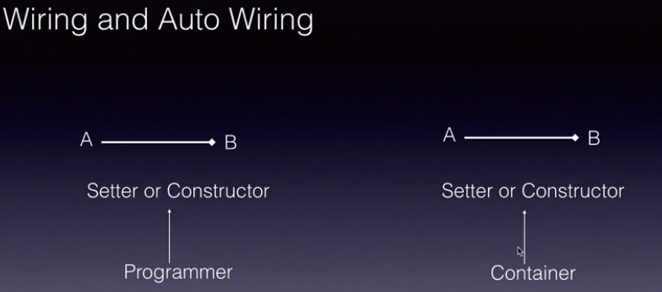

An object A depends on object B to do its job, then B is the dependency and A is the dependent object.

As a programmer, you have configured the dependency injection

in the config.xml using the ref tag.

This process of linking the dependent and the dependency is called Wiring. In realtime applications, you will be wiring a lot of objects or a lot of dependencies together.

If this process is done by the programmer, then it is called bean wiring.

And if this process is done by the container itself, the Spring container itself, then it is called auto wiring.

**Ways of doing AutoWiring:**

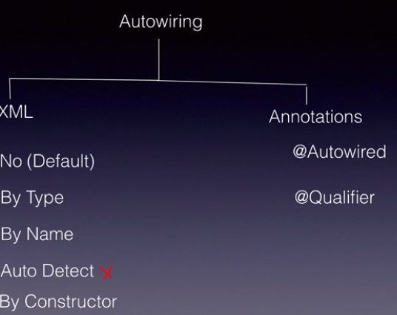

Auto Detect is only available till Spring 2.0, will not be used from Spring3.X. use attribute autowired=”byType/byName/constructor” as requirement in <bean> tag declaration.

In case of Annotations, use Autowired over setters of reference type objects. Autowired can be used on setters, on field levels, and also on constructors.

Using @Qualifiers(“address”) with @Autowired: using Qualifiers you can tell the spring container to find a bean with the given name, then inject it in the bean.If not found “NoSuchBeanException”.

**StandaloneLists:**

Whe n we pass collection from config.xml, it is local for that class and can not be used outside. Also by default List passed is treated as an ArrayList, map is treated as LinkedHashMap. What if I want to change the type of collection passed.

In such case standalone collection use comes into picture. STEPS to implement Standalone collections:

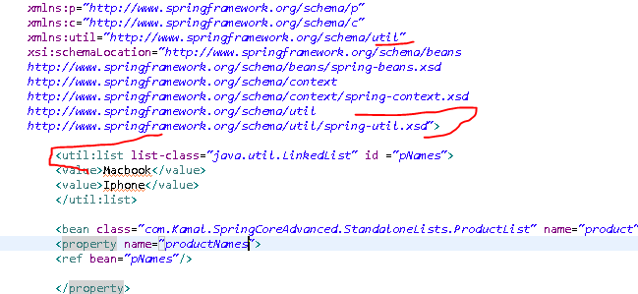

1. copy the util schema and namespace.
2. Then create collection using this format (util: Collection collection-class=””)

**Advantages: you can control the type of collection. Second , it can be used globally as a reference to other classes also.**

**StereoType Annotations** 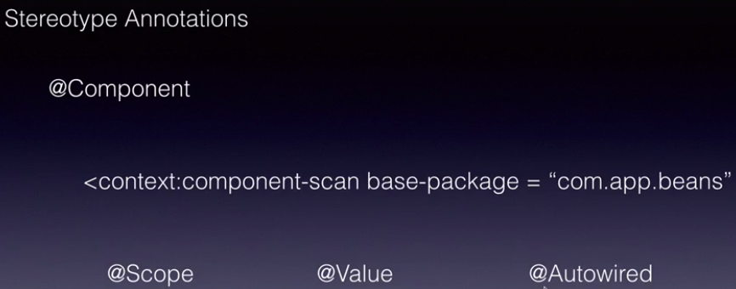

Till now , we did the object creation using XML, (by providing the bean class in bean Tag). StereoType annotations are used to perform object creation using annotations. For this use **@Component** over the bean class for which you want the object to be created. By default it will create the object in small case.

Ex- for Instructor class (instructor) object will be created. You can explicitly change the object name in @Component(“name”) over the class to give a more meaningful name.

@Value annotation can be used to pass values for the primitive types, collection type fields.

Once the object is created, you need to inform the container to search the class in base package. Using <context:component-scan> tag.

@scope can also be used to define scopes. @Autowired can be used to perform autowiring of reference type classes.

We can use @Value for collection type also, for that we need to define <util>schema in config.xml. And use the id of list over field in Bean class. @Value(“#{topics}”). So here topics is the id you have defined in config.xml. This is Spring Expression Languge(SpEL). SpEL can be used over expressions(“#{664+45}”) and also over collections.

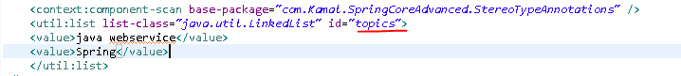

We can also use static methods/Static variables/Strings/Boolean Types in expressions :

Methods : @Value **(“#{T(java.lang.Math).abs(-99)}”)**.

Variables: @Value**(“#{T(java.lang.Integer).Integer.MAX_VALUE}”).**

Strings: @Value**(“#{‘Kamal Rajput’.toUpperCase()}”). Or using new java.lang.String(“”).method**

Boolean: @Value("#{2+3>5}")

**private** **boolean** Active;

**Injecting Interfaces**

Till now , we were injecting class objects , but in real time projects, we mostly work with interfaces.

By Creating an Interface, we provide implementation of interface. Implementation of one interface

is injected to other interfaces.

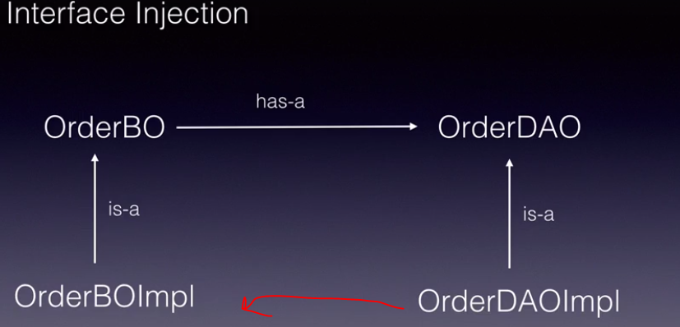

Here implementation of orderDAO will be injected in implementation of orderBO.

**Spring JDBC**

Along with DI, Spring simplifies the way we use several java technologies like JDBC, ORM, JMC etc.

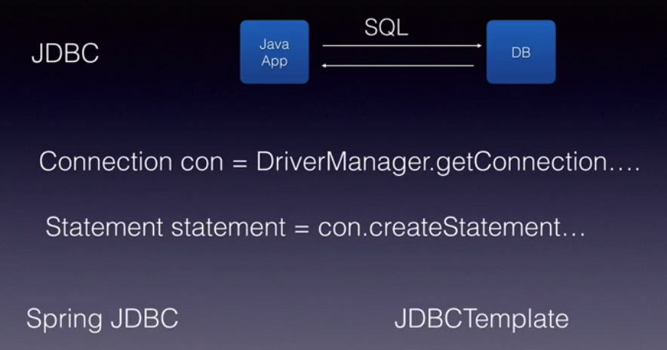

When JDBC is used, we need to write the above code in many classes,which is quite repetitive. Spring simplifies JDBC by providing a class called **JDBCTemplate. JDBCTemplate** is a combination of JDBC tech. + Template Design Pattern. Template carries all the common code(boilerplate code) and reduces the amount of developer work.

To use JDBC template, we need to implement **Java.Sql.DataSource** interface.

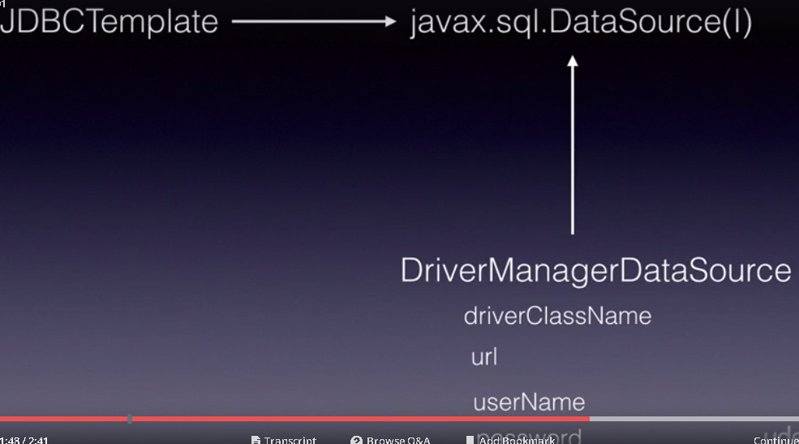

DriverManagerDataSource is an implementation for DataSource interface, it takes 4 arguments(driverclassName,url,username,pwd). We will create this bean (DriverManagerDataSource) and inject into **JDBCTemplate**.

JDBC Template provides various methods : like **update(String sql)**, **update(String sql,Object args).**

**Steps**: Create a datasource.

Inject into JDBC Template.

All this happens in config.xml

**Creating DTO & DAO:**

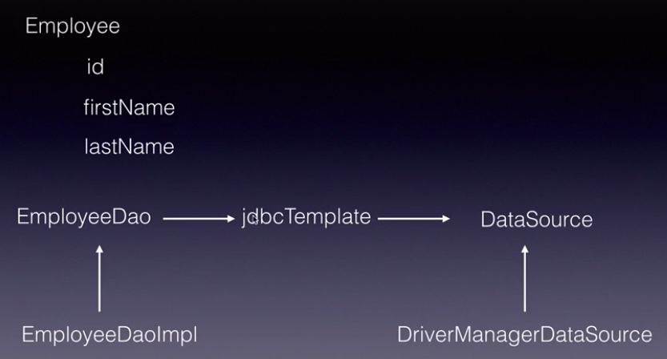

Here Employee : bean or DTO

EmployeeDAO : DAO object which will use JdbcTemplate or lets say JdbcTemplate will be injected into EmployeeDAO.

JdbcTemplate has access to Update method which can be used for insertion , deletion and updation.

For performing select queries , jdbc has two methods :

1. queryForObject(**String sql,RowMapper<T> rm, Object …args**) which returns only a single row.
2. query(**String sql,RowMapper<T> rm**) which returns multiple rows.

**RowMapper**  is an interface that we need to implement to map resultSet to the object that we create. 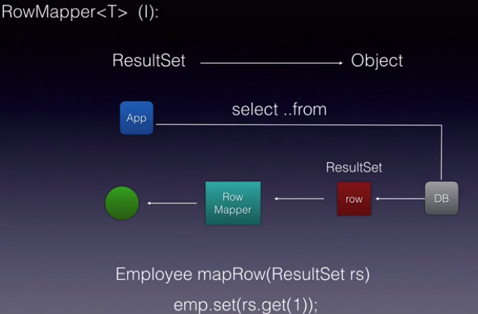

**SPRING ORM**

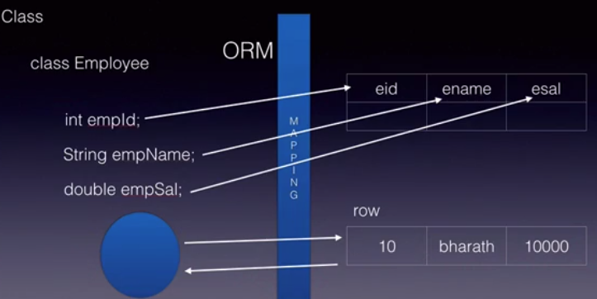

Spring ORM is an Object relational Mapping tool. It is used to perform object to relational mapping.Objects can be converted into DB rows, and rows can be converted back to Objects.

It generates SQL queries on the fly without explicitly creating it .

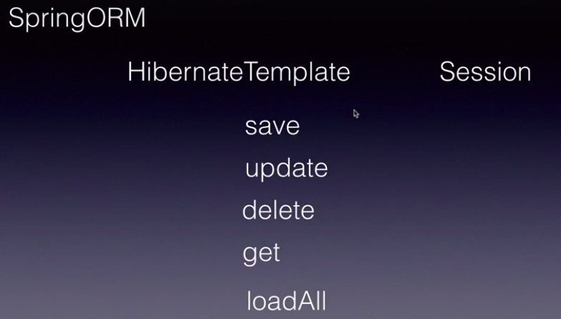

Just like how Spring made it easy for us to use JDBC by providing a Spring JDBC template.It also makes it easy to use ORM tools like Hibernate by providing **HibernateTemplate**. It hides all the boiler plate coding like creating a hibernate session etc; and we can simply use the HibernateTemplate and execute operations against a database such as save, update, delete, get which returns one record, loadAll which returns multiple records as a list of objects.

All these methods here deal with objects. They take objects, save them into the database .

**How things work using HibernateTemplate:**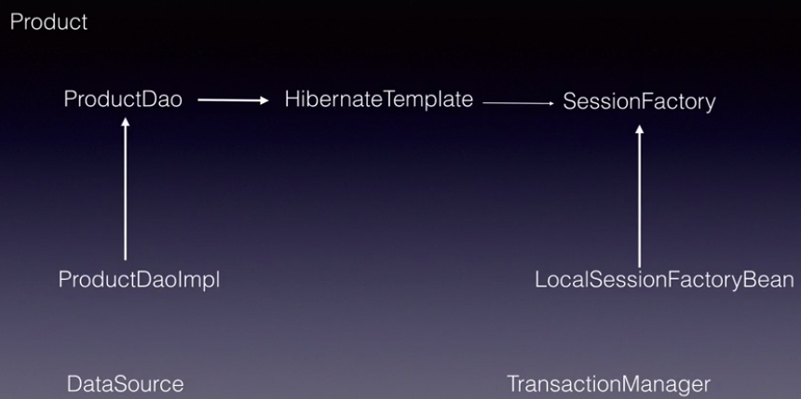

 Any application that uses HibernateTemplate will have the following design.

Usually, for example if we are dealing with a entity or table called **product**, we'll create a Java bean called

**product**, we'll mark it with all the annotations or the mapping information against the database table will

be provided.

And then we create the product Dao which will have all our database code. This is the interface. We implement it.

And this DaoImpl will depend on HibernateTemplate. The HibernateTemplate in turn uses the **SessionFactory**

bean which is an interface. This **SessionFactory** takes care of establishing the connection and all

that. it provides the hibernates session at the end.

We simply give the **SessionFactory** bean to the **HibernateTemplate** and the rest of it will be taken care by the HibernateTemplate.

An implementation of SessionFactory is LocalSessionFactoryBean from Spring.

We need **transactionManager** when we do write operations against a database to ensure that either all of them fall in one transaction, either all of them execute or they dont. Ex- in case of Money Transfer.

There are multiple Transaction managers provided like :**hibernateTransactionManager**, **JdbcTransactionManager**.

To use transactionManagement , use it <tx:annotation-driven>, and also use @Transactional annotation on the method you want to be a transaction. Everything in this method will happen in one transaction. If exception arises, rollback will be performed.

====================================================================================

**LocalSessionFactoryBean** takes 3 arguments: **dataSource,hibernate.properties,annotated Classes.**

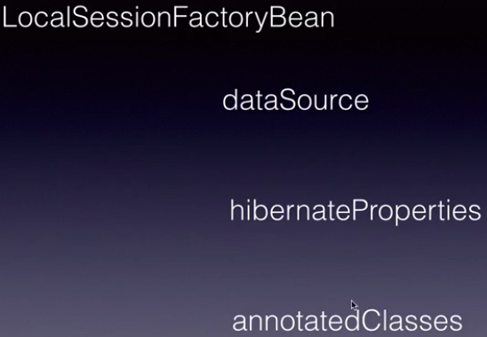

In **Hibernate.properties(key:Value),** we need to define some properties like hibernate Dialect which will generate sql for Different databases.

Hibernate_showSql : bydefault this is set as false.

Mapping is performed in **Bean** class :

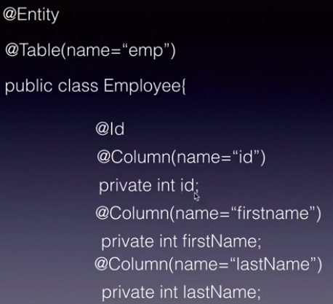

Hibernate has : **get(.class,int variable) –** which returns only one record.

**loadAll(entityClass)** –which return multiple records.

**SPRING MVC**

Spring MVC is used to design dynamic web applications. It internally uses three different design patterns,

the **front controller**, the **handler mapper** and **view Resolver** to implement the MVC design pattern.

When a request, a HTTP request comes from a client the very first component that will handle

it is the **Dispatcher Servlet** which is an implementation of the **front controller** design pattern.

It stands at the front and it handles all the incoming requests.

We simply configure this dispatcher servlet in the **web.xml** of our web application, which is the

deployment descriptor. The dispatcher servlet is from Spring framework. We'll not be writing any servlets.

We'll simply use it and configure it in our web.xml. Once configured, the Dispatcher servlet will take the incoming request,uses a HandlerMapper,again this is from Spring.

It internally calls the HandlerMapper which knows which controller class should be invoked.

Depending on the url pattern the HandlerMapper will map the incoming request to a controller. Controller

is a POJO class which we create and we mark it with a stereotype annotation from Spring called

**Controller**, Controller is the annotation. The Controller class inside a Controller class,

we will implement a method which will create a **ModelAandView**. Model represents the data in our application and view is the next page that should be displayed to the end user, it's just the name.

And at the end we return this ModelAandView to the dispatcher servlet.. Dispatcher servlet will take the view name and it will invoke a View Resolver which is a very important component

again. The View Resolver takes the view name and it will append a prefix and suffix to it.

The prefix is the location of that view on the server and the suffix is the extension for the View.

This way, the controller is not coupled with a particular view.

For example we can have a view location on the server which could be WEB-INF pages.

And tomorrow if we want to move it to a different location we can simply change it in the configuration

file instead of touching the Controller.

Similarly, if we want to switch from a JSP to JSF tomorrow we can do that by simply changing the

suffix in the configuration without touching our controller.

Finally this View Resolver will return a view back to the, complete view back to the Dispatcher servlet.

The Dispatcher Servlet will take the view and it will, that particular page can use the model or the data

if there is data and it will render that page back to the client.

To summarize once again, the client request comes in to the Dispatcher servlet. The Dispatcher servlet

will use the HandlerMapper, invoke a controller. Controller will create a ModelAandView. Model is optional.

The data might be there or might not be there for a particular request but at the end the Controller should

always return the name of the view. That view name will be given to the View Resolver. The View Resolver

will append a location which is the prefix and an extension which is the suffix. The Dispatcher

Servlet will then take that page, give it the model if there is model. That page will use the model

and it will display the end result to the client.

Before we wrap it up, this is how the View Resolver will look like. The prefix, the view name and the suffix.

The prefix could be views under your WEB-INF or somewhere in your web application.

The view name would be hello.

This is what a Controller will return, just hello. And the extension is .jsp. We configure this locationand the .jsp in the Spring configuration file.

And this hello will be returned by the Controller.That way everything is loosely coupled, we can simply change this folder in the configuration if required in the future,if the folder changes. And also the dot extension can also be changed in the configuration, if we switch to JSF or some other technology we can switch the extension as well.

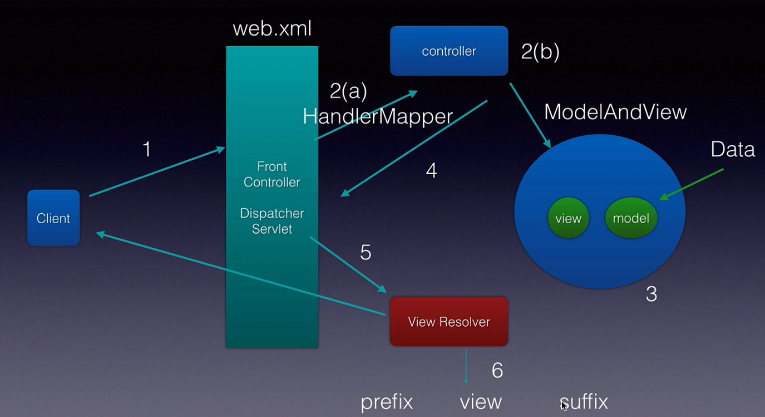

**Steps:**

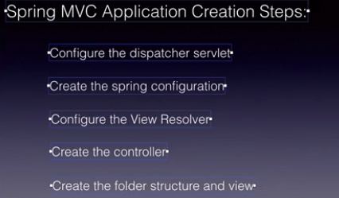

In web.xml , Dispatcher servlet is configured, url mapping is set as “/”, which means all request will be served.

Spring configuration is done in dispatcher-servlet.xml(this is the default name), **InternalResourceViewResolver**

is set in bean class.Properties such as prefix and suffix will be created also. Create controller class, mark it with @**Controller** annotation, create method ModelAndView (use @RequestMapping on the method) with the argument as the name using which you want to call jsp. Set the view using **modelAndView.setViewName(hello).** Once the server is up, the page will be rendered using hello on Request. A jsp should be created which you want to display and it should be present under prefix(location).

So in all the applications, the major flow is to send the data from one page to another or from one component to another. It can happen in two ways:

1. Controller to UI
2. UI to Controller

**Sending Data from Controller to UI:** Data to be sent include (**primitive types, collection, objects**)

Data from controller to UI can be send in two ways :

* **one** is by setting primitive types using modelAndView.**addObject**(Key,Value)
* then the data can be fetched using request.getAttribute(key) in UI(.jsp files)
* **Second** way is using JSP expression language (${id}) .

Even the objects, and collection object can be send using addObject() method. You just need to create a controller class for object/Collection type and set view Name so that it can be rendered using the name on UI.

**Sending data from ui to Controller:** can be sent using **HTML page**, and **Query Parameters**.

**Using HTMLPAGE**

So in this case, the data from html page will be sent to controller. Lets take one usecase, where you have one html page named as **Registration,**on this page you have 3 fields(id,name,salary). Once the data is entered, it will be added to a bean(model class). Fields name on html should be same as in bean class. Once the bean is created , it will come to controller class( use @ModelAttribute over the argument) to map the data of bean to the entity.

Now you can add it into modelAndView.addObject, and redirect it to different page to display the values.

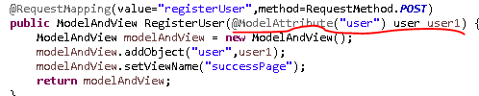

So here @ModelAttribute is mapping the values coming from html to User Entity(bean) class and redirecting it to successPage.

**Using QueryParams**

In this case the data sent in url will be mapped to the column names using @RequestParams(“name”) int varname; 

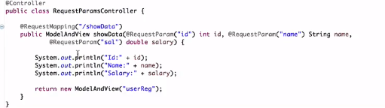

All the fields marked with @RequestParams are mandatory and if any of the field is not sent in url, 400 error will be thrown. To make it optional you can use it as below.

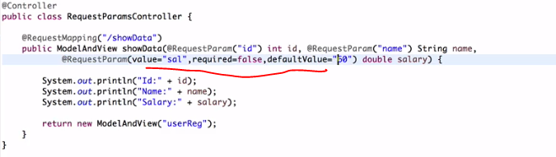

Even if we set it as required=false , and run, another exception will be thrown saying **primitive types can not be cast as null.**  So for this we set a default value.

**Using ModelMap & String View**

ModelAndVIew design is tightly coupled. Even if we don’t have to use model ,and only viewing fnality is covered, we still have to create ModelAndView object. So to cover up this limitation, We do have **ModelMap**

And **StringView.**

